

USPG Conference, Morning Prayer 26th July

Preparation: Silence
Opening Responses: (The words in bold are said together)
L: Creator God, source of eternity and time:
All: Be with us in this time.

L: Saviour of the world, healer of the nations:
All: Be with us in this place.

L: Breath of all that lives, of people near and far:
All: Stir within our lives

L: Maker-Spirit-Son, God of here and now:
All: Be present in our worship, that we may find new ways to be present in your world. Amen.

Confession:
L: God of life, we confess that there are many things about our own life and the life of the world which test our faith that you come to us in love. When this struggle overwhelms us:
All: Come to us in grace, O God.

L: When we let arrogance and ignorance come in the way of seeing and perceiving you at work in those different from us.
All: Come to us in wisdom, O God.

L: When we can only think of violence and force as the path to justice and peace. When our trust in the possibility of one human community wears thin:
All: Forgive us and give us a new vision of your love. Grant us a new openness to your persistent and prophetic presence in the unexpected. Strip us to be embraced by you in the visions and dreams of the weak and vulnerable.

Assurance of Pardon: (All Together)

May the creator God who enfolds us with wings of love as a bird protects her young, the redeeming God - our Lord and Saviour Jesus Christ, and the sustaining God - the accompanying Holy spirit – who leads us into new ways of being alive in Christ, forgive us our sins, free us from our shortcomings and release us into the freedom of the children of God. Amen.

Song: Ubi caritas Et amor , Ubi caritas Deus ibi est (Taize)

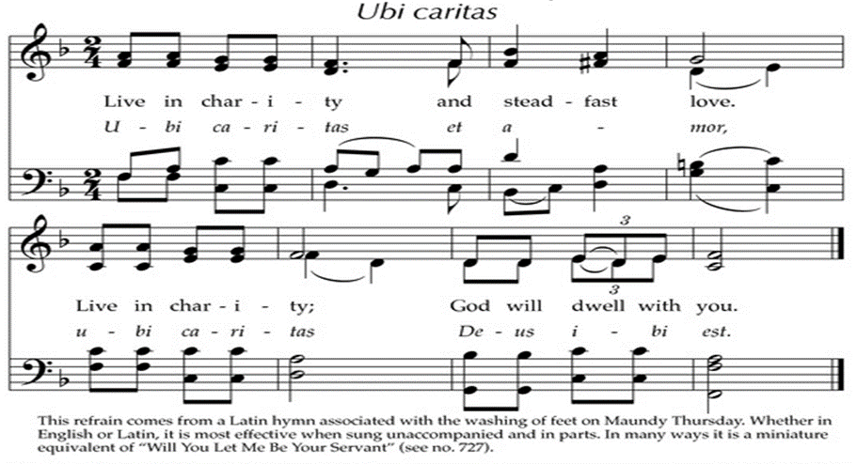

Intercessory Prayers:

For the Work and Witness of USPG:
Eternal God, Alpha and Omega, we thank you for USPG and its partners, we offer you our work and witness together as tokens of our gratitude and signs of our dedication to you. As we stand on the threshold of changing times help us in humility to learn from the failures of the past and build further upon that which has proved fruitful so far. As we seek to continue our journey of service and solidarity may we be grounded in faith, inspired by love and sustained by hope.

Response: (To be sung): O Lord hear my prayer, O lord hear my prayer, when I call answer me. O Lord hear my prayer, O Lord hear my prayer. Come and listen to me. (Taize)

For the Church: Jesus Christ, the bedrock of our faith and the cornerstone of the Church, we thank you for your Church worldwide, remembering especially the Anglican Communion. Make us, as your body, a visible sign of the unity you desire and an instrument of the wholeness you promise. Empower us to be more vibrant in our witness, persistent in our prophetic presence and resolute in our hope in you so that your will may be brought to fruition on earth as it is in heaven.

Response: (To be sung): O Lord hear my prayer, O lord hear my prayer, when I call answer me. O Lord hear my prayer, O Lord hear my prayer. Come and listen to me. (Taize)

For Justice, Peace and life: God of justice and peace whose will for the world is Shalom. We pray for the whole created order in its beauty and brokenness. We pray for transformation wherever there has been an abuse of power, repentance wherever there has been a wilful turning away from responsibility and restoration wherever there has been a marring of your image in humanity.
In our relationship with the earth teach us to heal and not to harm, in our relationships with others enable us to receive and not reject.

Through your life-enhancing Spirit direct us in our strength and inspire us in our weakness that we may join in with the movement of your whole creation towards wholeness, justice and peace.

Response: (To be sung): O Lord hear my prayer, O lord hear my prayer, when I call answer me. O Lord hear my prayer, O Lord hear my prayer. Come and listen to me. (Taize)

The Lord’s Prayer: These, and the other prayers of our heart, we bring before God using the words of the Lord’s Prayer, each in a language of our choice.

Benediction: (Ephesians 3:16-21)

All: Now may the Triune God give us the power to comprehend the breadth and length and height and depth of the love of Christ that surpasses knowledge, so that we may be filled with the fullness of God and live and work to God’s praise and glory. And now to the one who by the power at work in us is able to accomplish abundantly far more than all we can ask or imagine, be all glory and praise, now and forever. Amen.

